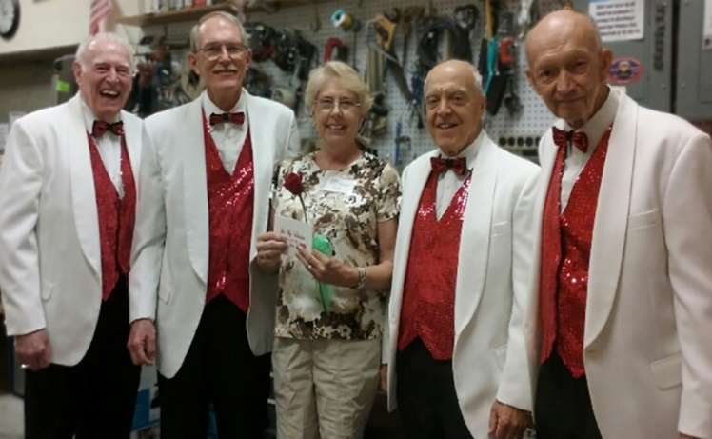
“I Love You!”
Order a Singing Valentine for your sweetheart who will receive a red rose, a card, and two beautiful love songs sung by a Barbershop Quartet from the Sarasota Chorus of the Keys.
WHEN: Monday, Feb. 14, 9 am to 8 pm or
Sunday, Feb. 13 from 1 to 6 pm.
ORDER FORM

Your Sweetheart’s Name: _____________________________________________
ADDRESS & DIRECTIONS: (Include ZIP & Exact Location (i.e. name of business, room/floor no.) _____________________________________________________
PRICES: $40 cash or check payable to: “Chorus of the Keys” (Requests after 5 pm on Feb. 14 or on Sunday, Feb. 13 - $50).
Circle Date & Time: Monday, Feb.14 (9-12, 12-3, 3-5, 5-8) or Sunday, Feb. 13 (1-6).
From Donor (Name on valentine card): ____ _____________________
Phone ______ _________ If need arises, may we call the from donor phone prior to the quartet arrival? YES or NO
From Donor Message on Card:
______________________________________________________
Mail Check Payable to Chorus of the Keys to: Dave Richards, 4464 Cayo Grande Dr., Sarasota, FL 34233 or Call (941) 266-2711 or Email: richards70@msn.com
NOTE: For issues on Sunday (Feb.13) or Valentine’s Day (Feb.14), Call Dave for assistance.

